Climate warming not only amplify cooling demand but also undermine sleep quality

Abstract
The impact of rising ambient temperatures on sleep under climate change is becoming increasingly concerning but remains underexplored.
Urbanization is amplifying the challenge.

Warmer nighttime temperatures caused considerable sleep disruption, with a total loss of 1383 min per person

Main
Adequate sleep is a fundamental biological imperative for human physical and cognitive resilience. Any systemic disruption cascade into profound public health consequences, precipitating chronic respiratory diseases, metabolic and mental health disorders, and elevated mortality [XX]. As the global climate warms, temperatures are rising disproportionately fast, directly compromising the human body’s thermoregulatory capacity during sleep. Recent projections indicate that unabated climate-driven temperature anomalies could inflict severe sleep loss, already manifesting as a 14.9% increase in sleep deprivation in China compared to historical baselines. Such warming climate combined with dense population in cities transforms nighttime heat exposure into an insidious and escalating global health crisis.
Despite growing recognition of heat-induced sleep disruption, current climate-health macro-assessments harbor a critical mechanistic blind spot: they predominantly extrapolate human health outcomes directly from outdoor meteorological weather data. This paradigm fundamentally overlooks the "invisible building buffering effect”, a complex indoor thermal mediation governed jointly by passive structural sheltering and active mechanical cooling (AC), as illustrated in Fig. 1a. Since humans spend the vast majority of time (including sleep) indoors, the building’s envelope acts as a critical thermal mediator that fundamentally reshape the magnitude, timing, and spatial distribution of heat exposure. As demonstrated by the physics of explicit structural heat transfer, buildings introduce a temporal lag by absorbing solar radiation during daytime hours and trapping it as delayed terrestrial heat release precisely during the nocturnal sleep period [XX]. Bypassing this indoor reality obscures the true spatial heterogeneity of thermal stress and severely miscalculates actual human vulnerability. While recent micro-level epidemiological studies utilizing wearable devices (e.g., smartwatches) have attempted to track actual indoor sleep exposures, these observational approaches remain confounded by stochastic human behaviors and cannot feasibly scaled up to map city-wide heterogeneities due to the data coverage limits. Consequently, quantifying this building buffering effect across vast urban scales remains a formidable challenge.
This methodological blind spot is particularly perilous in densely populated urban centers, which concurrently house over 50% of the global population [XX]. When passive building buffering fails under worsening heatwaves, populations are forced to retreat to active mechanical cooling (i.e., air conditioning, AC). Relying on AC to secure physiological comfort creates a volatile Climate-Energy-Health Nexus that escalating heat triggers more intensive cooling, resulting surge in electrical demand strains urban power grids, trapping cities in a vicious cycle of maladaptation. Untangling this nexus requires shifting the present analytical framework from outdoor weather exposures to the high-resolution internal realities of where actual sleeping occurs.
To bridge this critical spatial and mechanistic gap, we present a highly resolved, physics-based analytic engine powered by the Building Energy Sand Table (BEST). Moving decisively beyond empirical statistical correlations, BEST employs a bottom-up, mechanistic simulation approach to reconstruct realistic thermal environments and energy performances across a massive national portfolio of over 40 million individual buildings spanning more than 300 megacities in China. By operating at an hourly resolution over full-year cycles, this analytic engine captures the nuanced heat transfer physics of individual building archetypes. We subsequently integrate these high-fidelity physical simulations with a physiologically informed indoor discomfort metric (Predicted Mean Vote, PMV) to precisely quantify sleep-disruptive hours (Fig. 1b).
We further trace the granular spatiotemporal evolution of sleep-period discomfort driven by projected warming scenarios (SSP126, SSP245, and SSP585) through the mid-century. By dissecting the thermal discomfort landscape from the macro-urban scale down to the intra-building vertical stratification (the top-floor penalty) and superimposing demographic structures, we map the emerging dual-threat of aging and overheating. Ultimately, we quantify the systemic cooling energy penalties strictly required to neutralize these indoor thermal distresses. In doing so, we establish a robustly validated, physics-based analytical engine capable of resolving the coupled thermal-health-energy dynamics at an unparalleled building-by-building, floor-by-floor and hour-by-hour granularity across entire megacity landscapes. Overall, our findings provide high-fidelity and actionable insights for quantifying the sleep-period thermal discomfort, safeguarding vulnerable demography, and proactively breaking the feedback loop of urban extreme heat and excessive operational energy demand.

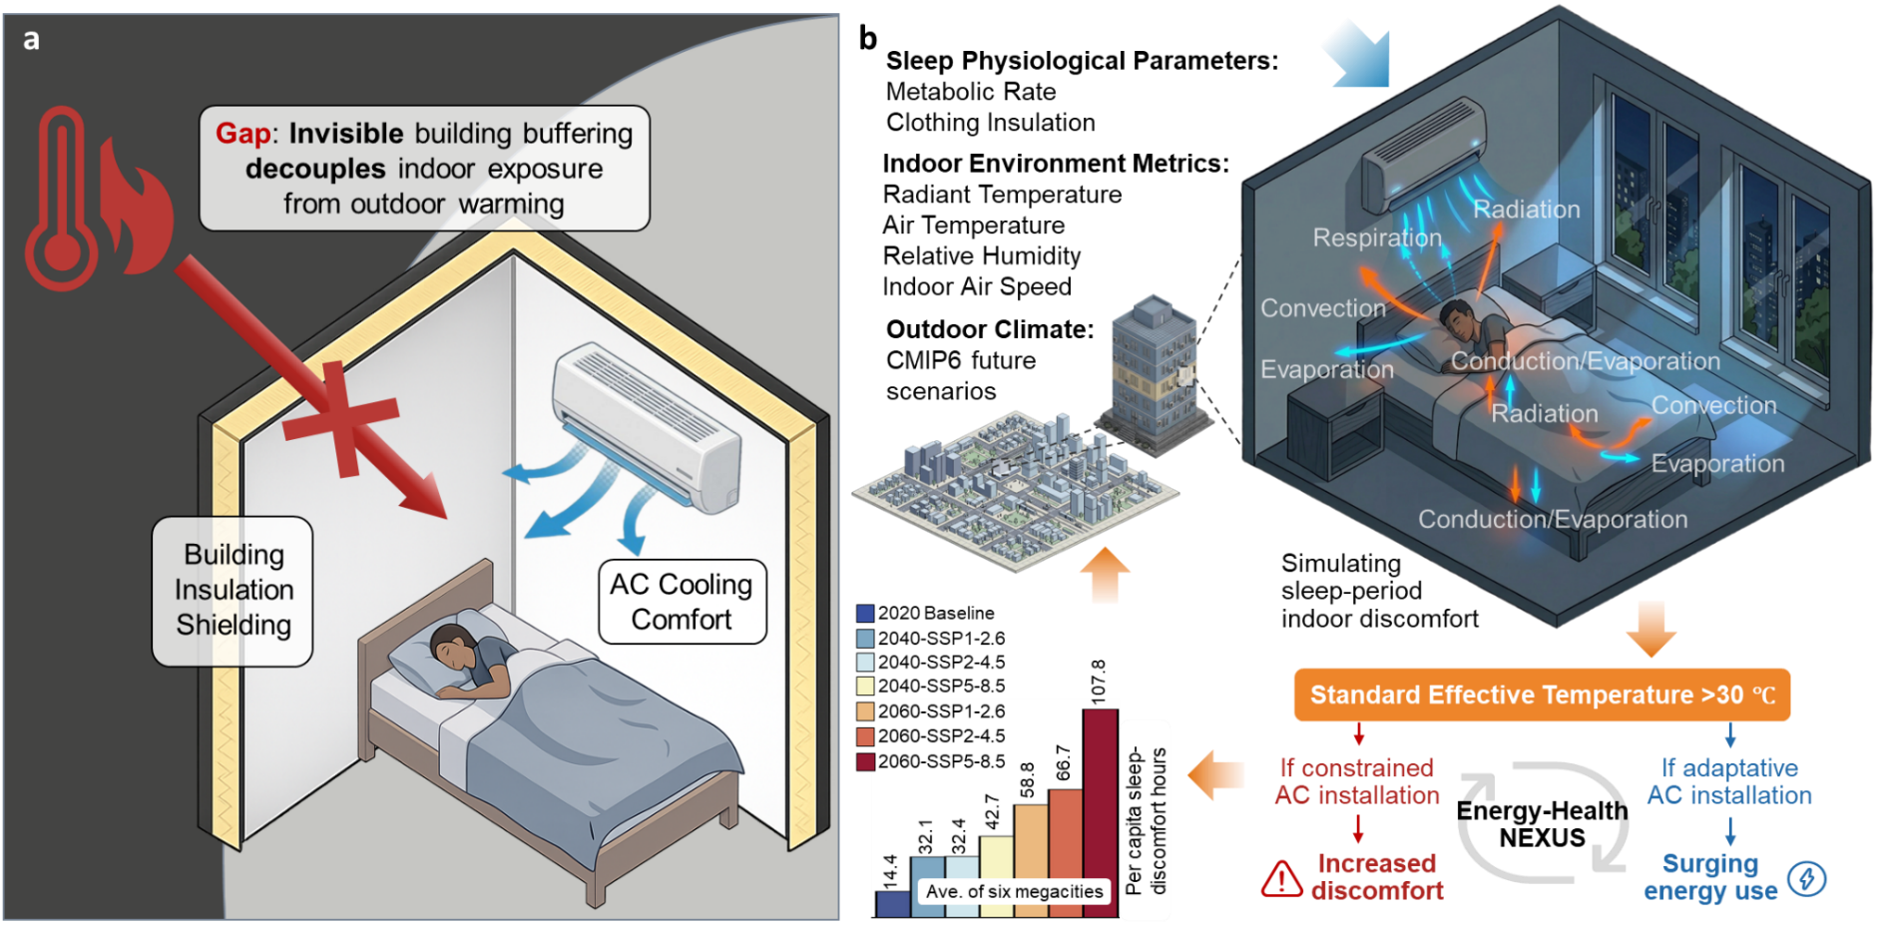
Fig. 1 Integrated modeling framework resolving building-buffered indoor heat exposure during the sleep period and the energy-health nexus. a, Conceptual distinction between outdoor meteorological forcing and actual human exposure. The schematic illustrates how building envelopes and mechanical cooling buffer the indoor heat exposure, emphasizing the limitations of most urban epidemiological assessments solely driven by outdoor temperatures. b, The bottom-up thermodynamic and physiological simulation approach. Downscaled meteorological projections, building physical properties, and human sleep-state physiological variables are integrated to resolve the dynamics of heat exchanges and indoor microclimates. The sleep-period discomfort is then quantified against physiological distress threshold (Standard Effective Temperature > 30 °C). Based on this threshold, the framework simulates two pathways of indoor thermal adaptation: (i) exacerbated human discomfort under constrained cooling, (ii) the translation of health risks into systemic cooling energy demands via active AC adaptation. The bottom-left inset shows the projected regional variations of aggregate thermal penalties under current and future climatic scenarios.

Spatiotemporal heterogeneity of sleep-period thermal discomfort
Our multi-city analysis across latitudinal gradients moves beyond isolated case studies to provide a synchronized national perspective on indoor heat exposure. The six megacities, Beijing, Shanghai, Guangzhou, Shenzhen, Wuhan, and Xiamen, represents a cross-section of three densely populated climatic zones as shown in Fig. 2a. Notably, all six cities maintain a robust air-conditioner (AC) penetration rate exceeding two units per household. By integrating high-resolution meteorological forcing with the “invisible” buffering capacity of combined buildings insulation and AC operations, we simulated the sleep-period discomfort hours at a granular scale for a whole year. The results reveal an alarming decadal escalation in sleep-period thermal distress across all investigated cities under varying Socioeconomic Pathways (SSPs). Compared to the 2020 baseline, the annual discomfort hours are expected to surge significantly by 2040 and 2060, particularly under the high-emission SSP5-8.5 scenario (Fig. 2b). Even in the Cold zone (e.g., Beijing), the emerging surge in sleep-period discomfort signals a northward shift of heat-related sleep deprivation, structurally suggesting that the traditional climatic barriers (i.e., cool summer night) to sleep-period heat stress are rapidly eroding.
To ground-truth our physical simulation, we cross-referenced the modeled hotspots with real-world digital footprints in Shanghai, utilizing a massive dataset of geotagged social media (Weibo) records pertaining to sleep deprivation. The results demonstrate a [XXXX量化词] spatial congruence between modeled discomfort zones and the density of public complaints regarding “insomnia” and “too hot to sleep” (Fig. 2c). The marginal density distributions confirm that the physical model accurately captures the geographic epicenter of the thermal distress. This empirical anchoring bridges the gap between simulated physical parameters and subjective physiological human experience, robustly validating our model’s reliability in representing real-world urban health burdens.
High-resolution spatial mapping further unveils a distinct, non-uniform radial expansion of thermal penalties within each megacity (Fig. 2d1-d6). Thermal discomfort is not randomly dispersed but exhibits a strong core-periphery clustering pattern, with urban centers (marked by red stars) serving as persistent high-exposure enclaves. As we transition from 2020 to 2060 projections, these “discomfort islands” undergo significant spatial coagulation and outward sprawl, effectively swallowing residential zones across entire urban landscape. This intensifying spatial heterogeneity imposes a disproportionate health burden on residents in high-density urban cores. Even these cities are already well-equipped with AC, the intensifying climate forcing threatens to breach the existing building buffering capacity, thereby creating localized “thermal traps” that warrant extreme vigilance and targeted adaptive interventions.
Notably, although southern cities like Shenzhen and Guangzhou share similar regional weather conditions, they exhibit distinct and highly asymmetric trajectories of thermal distress. This divergence is primarily driven by local variations in individual building physical attributes and overall urban morphology. In these highly populated and vulnerable megacities, what we currently consider as extreme years are projected to become the future norm.

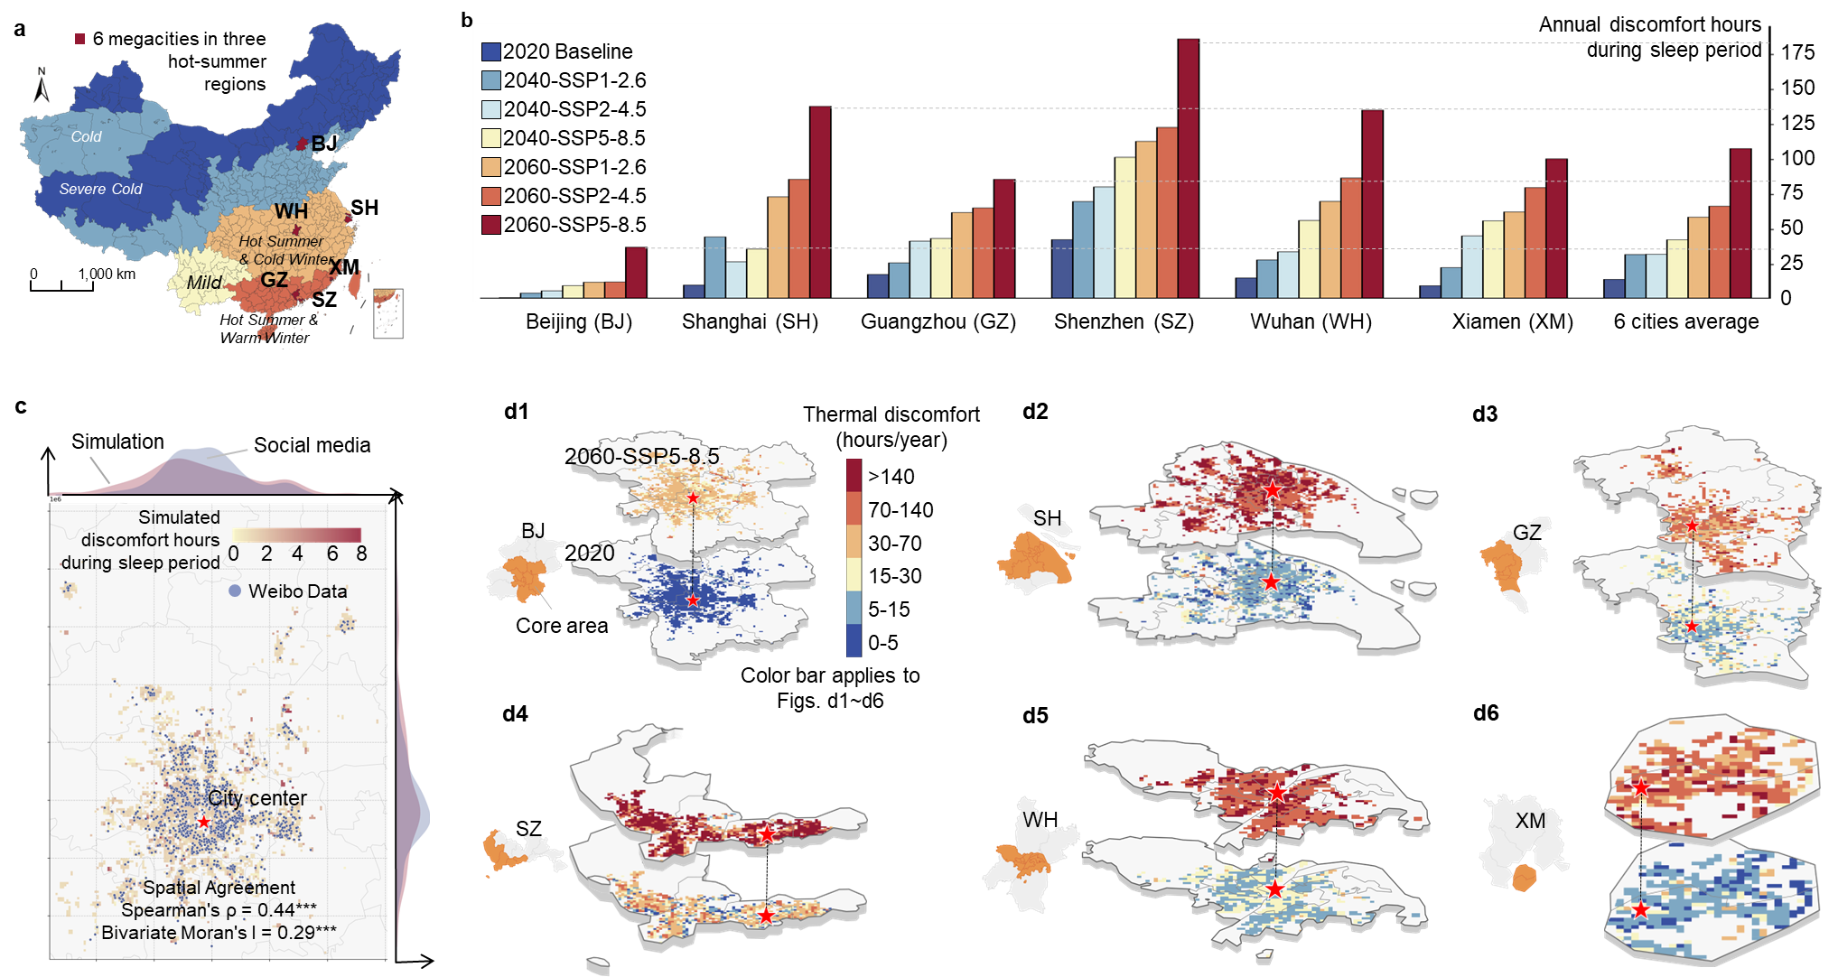
Fig. 2 Spatiotemporal divergence of sleep-period thermal discomfort for 6 representative megacities across multidimensional climate zones. a, Locations of the 6 selected megacities encompassing three massive population-dense climatic zones (Cold, Hot Summer & Cold Winter, and Hot Summer & Warm Winter) in China. b, Baseline (2020) and projected decadal (2040 & 2060) escalation of annual sleep-period thermal discomfort hours across multiple SSP trajectories. c, Empirical spatial validation utilizing geotagged social media (Weibo, the largest platform in China) data in Beijing. The marginal density distributions indicate a spatial congruence (Spearman’s ρ = 0.85, Bivariate Moran’s I = 0.29, p < 0.001 for both index]) between the model-simulated sleep distress hotspots and real-world sleep deprivation reports from the public, firmly anchoring our physical model’s reliability. d1-d6, Spatial clustering and rapid radial expansion of severe sleep-loss penalties spreading from urban cores (marked with red stars), mapped by contrasting the 2020 baseline against the worst-case scenario (2060-SSP5-8.5).

Similar climates but diverse thermal resilience
To isolate the buildings’ buffering effect on sleep-period heat exposure at city scale, we focused on the climatological twin cities of Guangzhou and Shenzhen. Despite their geographical proximity and nearly identical regional weather patterns, the two megacities exhibit a distinct divergence in sleep-period thermal discomfort (Fig. 3a). Notably, under the most severe emission scenario (SSP5-8.5, 2060), the projected annual discomfort hours per person in Shenzhen reaches 186.2 hours, which is more than double the 85.9 hours projected for Guangzhou. This unexpected difference suggests that the building buffering capacity, which serves as a primary shield for residents, is profoundly related to the specific urban archetypes, even when facing localized climate forcing of similar intensity.
To explicitly decouple macro-climate forcing from actual human exposure and validate the role of the building buffering effect, we focused on the climatological twin cities of Guangzhou and Shenzhen. Despite their geographical proximity and nearly identical weather patterns by exhibiting indistinguishable annual mean outdoor temperatures across all future scenarios (Fig. 3a), the two megacities exhibit a distinct divergence in sleep-period thermal discomfort (Fig. 3b). Notably, under the most severe emission scenario (SSP5-8.5) by 2060, the projected annual discomfort per person in Shenzhen reaches 186.2 hours, more than double the 85.9 hours projected for Guangzhou. This drastic difference suggests that the building buffering capacity, which serves as a primary shield for residents, is profoundly related to the specific urban archetypes, even when facing localized climate forcing of similar intensity.
This inter-city disparity is fundamentally rooted in the multidimensional heterogeneities of building landscape across the two cities. High-resolution Kernel Density Estimation (KDE) reveals that Guangzhou’s residential landscape is dominated by buildings with larger footprint areas and a prominent peak in low-rise structures (~10m), providing a more thermally stable indoor environment (Fig. 3c1 and c2). In contrast, Shenzhen’s residential stock is characterized by smaller-area units and a significantly higher proportion of mid-to-high-rise buildings (20–30m). The lower thermal inertia typically associated with Shenzhen’s smaller residential footprints, combined with higher vertical exposure, significantly accelerates external heat penetration into the indoor sleeping environment during the stagnant summer nights.
Furthermore, the shape factor (external surface-to-volume ratio) and building age distributions provide deeper insights into this morphological divergence. Shenzhen exhibits a significant rightward shift in its shape factor distribution compared to Guangzhou (Fig. 3c3), indicating more complex and less compact building geometries that maximize heat exchange with the ambient environment. This increased exposure surface acts as a thermal bridge, compromising the insulation-buffered cooling efficiency. Additionally, the concentration of Shenzhen’s building age, peaking sharply around 20–30 years, reflects the legacy of its rapid, high-density urbanization phases (Fig. 3c4); whereas Guangzhou exhibits a more staggered age distribution suggests a mix of historical and modern stocks with varying thermal performance.
By successfully isolating the city-scale buildings’ buffering effect on urban heat exposure, these findings underscore that building attributes are not merely passive envelopes but active modulators of climatic risk. Contemporary macro-assessments overwhelmingly rely on outdoor weather data to heat-related morbidity records, systematically ignoring a profound reality that modern populations spend roughly 90% of their time and virtually 100% of their sleep periods indoors [XXX]. The 2.1-fold divergence between Guangzhou and Shenzhen illustrates that even under identical localized climate forcing, high-density urbanization characterized by high shape factors and restricted footprints can structurally turning residential units into nocturnal heat traps. Therefore, without integrating high-resolution indoor building physics, any global or municipal estimation of heat-health burdens remains fundamentally incomplete and dangerously misleading.

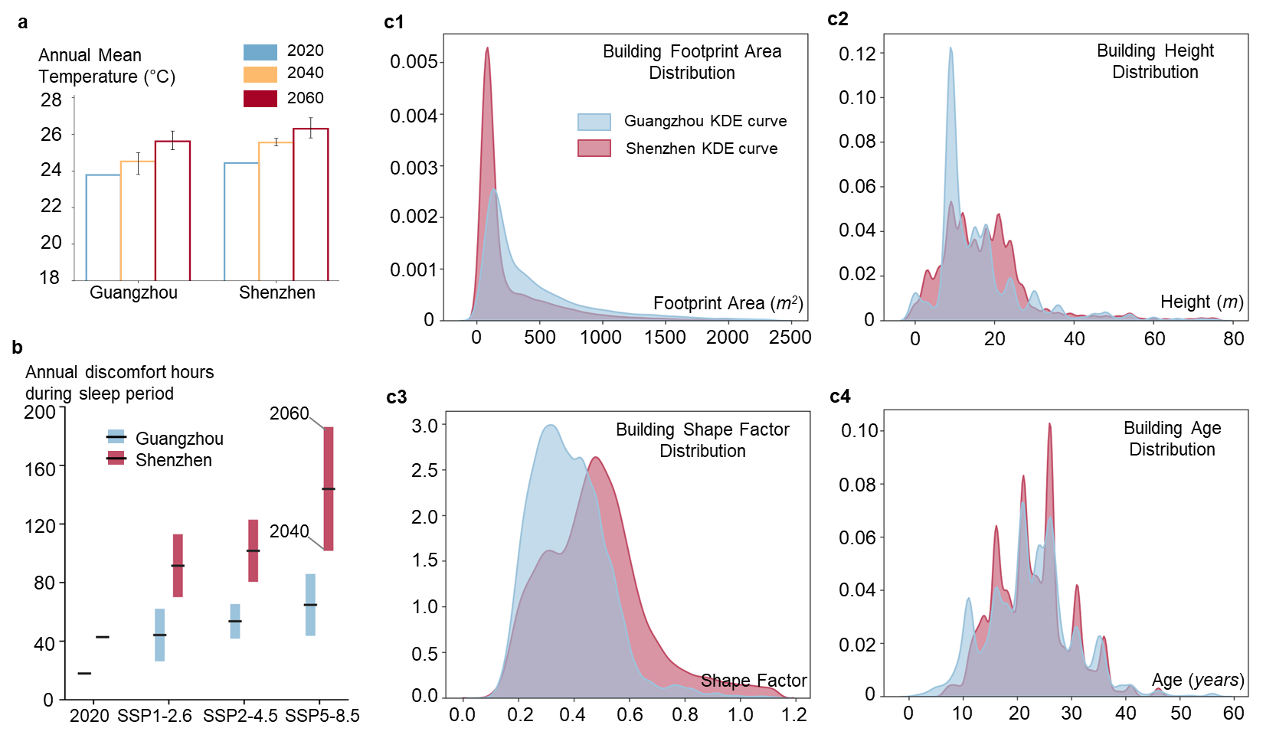
Fig. 3 | Unmasking the building buffering effect by comparing the divergence of sleep-period thermal resilience between climatological twin cities. a, Projected annual mean outdoor temperatures for Guangzhou and Shenzhen across historical and future scenarios, demonstrating a nearly identical macro-climate forcing baseline. b, Projected annual sleep-period discomfort hours. Despite sharing similar outdoor climates, the two megacities exhibit a drastic divergence in actual indoor thermal vulnerability; notably, under the SSP5-8.5 scenario (2060), indoor discomfort in Shenzhen (186.2 hours) is more than double that of Guangzhou (85.9 hours). c1–c4, High-resolution Kernel Density Estimation (KDE) reveals the structural archetypes driving this divergence: building footprint area (c1), building height (c2), shape factor (c3), and building age (c4). Extreme outliers beyond three standard deviations (>3σ) were excluded to accurately capture the representative archetypes of the building landscape.

Vertical thermal disparity and the top-floor penalty
Building upon the morphological vulnerability identified previously, we pivot to Shenzhen to advance our understanding from a 2D spatial landscape context into the three-dimensional indoor environment. By categorizing the city’s residential stock into representative structural archetypes (high-rise, mid-rise, and low-rise), we investigated the granular spatiotemporal evolution of sleep-period discomfort. The results expose a profound intra-building heterogeneity, demonstrating that thermal vulnerability is far from uniformly distributed; rather, it is critically dictated by vertical stratification.
High-resolution vertical profiling uncovers a systemic and pronounced top-floor thermal penalty across all structural archetypes (Fig. 4a1-c1). Unlike non-top floors that benefit from the shielding effect of superimposed structural layers, the uppermost units serve as the primary interface for unabated daytime solar accumulation. Consequently, the vertical distribution of discomfort hours is highly asymmetric. In high-rise buildings, the thermal distress curves remain relatively flat across the lower and middle storeys but exhibit a violent spike specifically at the topmost floor. Similar vertical inequities are observed in mid-rise and low-rise buildings, indicating an inherent structural disadvantage where top-layer residents bear a vastly disproportionate heat burden.
To mechanistically capture this vertical disparity, we tracked the hourly diurnal evolution of thermal discomfort within the indoor environment (Fig. 4a2-c2). The temporal dynamics reveal a prominent delayed heat release effect that detrimentally coincides with the human restorative sleep window. While daytime active hours typically correspond with periods when residents are away from home, the heat absorbed by the roof envelope gradually penetrates inward, triggering a massive surge in discomfort during the late evening and early nighttime (18:00–24:00). Across all building archetypes, the peak frequencies of thermal distress for top floors (red curves) consistently dwarf those of their non-top counterparts (blue curves).
Alarmingly, the temporal profiles indicate that this localized vulnerability is rapidly deteriorating. As climate forcing intensifies towards 2040 and 2060 under the high-emission SSP5-8.5 scenario, the nocturnal discomfort peak not only grows in absolute magnitude but also broadens significantly. The structurally compromised top floors fail to dissipate heat efficiently, causing the thermal distress to extend deeply into the core sleeping hours. This spatiotemporal intersection of vertical exposure and diurnal temperature lag structurally collapses the safe nighttime window, necessitating highly targeted, roof-specific architectural interventions rather than homogeneous city-wide adaptation strategies.
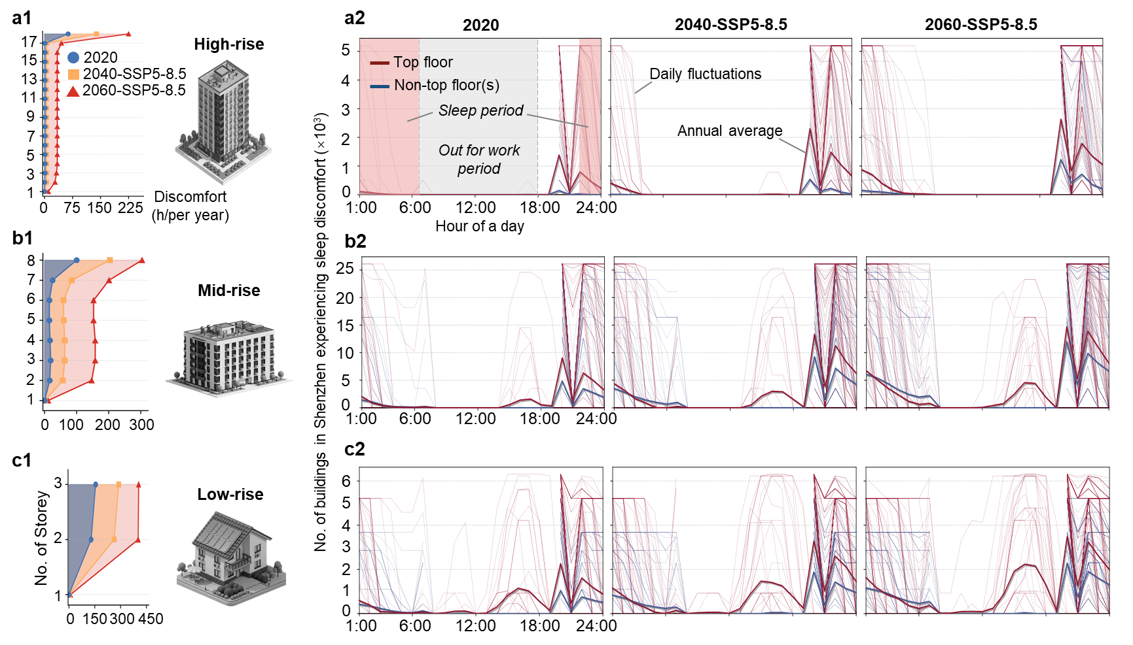
Fig. 4 Vertical thermal disparity and spatiotemporal top-floor penalty across residential archetypes. a1–c1, Vertical profiles of projected annual sleep-period discomfort hours for high-rise (a1), mid-rise (b1), and low-rise (c1) residential buildings. The curves demonstrate a highly asymmetric distribution with a violent spike at the uppermost levels, illustrating the pronounced top-floor penalty across baseline (2020) and future high-emission scenarios (SSP5-8.5 for 2040 and 2060). a2–c2, Diurnal evolution of thermal discomfort frequencies within the corresponding building types. Thick solid lines (red for top floors, blue for non-top floors) represent the annual average trajectories, while faded background lines capture daily fluctuations. Grey and light red shaded areas denote the typical unoccupied daytime periods (no one at home) and critical restorative sleep periods, respectively. The distinct peak overlaps with the sleep window manifest a delayed heat release mechanism, which disproportionately exacerbates the nocturnal thermal burden for top-floor residents as climate warming intensifies.

Emerging thermal and demographic co-vulnerability
While structural and spatial dimensions dictate the physical magnitude of urban heat, the actual realization of climate risk is fundamentally governed by demographic susceptibility. Older adults are physiologically more vulnerable to nocturnal thermal stress, rendering the intersection of extreme indoor discomfort and an aging population a critical public health frontier. By superimposing highly-resolved building-level demographic profiles onto our spatiotemporal thermal simulations, we formulated a bivariate vulnerability matrix to track the shifting landscape of climate-health risk across six major megacities in China.
Under the current baseline (2020), the systemic threat remains largely nascent. As illustrated in the bivariate spatial distributions (Fig. 5a1–a6), cityscapes are predominantly characterized by low-risk zones (light blue) or isolated single-stressor regions, either housing aging demographics with low thermal stress (dark blue) or experiencing emerging thermal discomfort with younger populations (orange). The most critical zones concurrently suffering from severe nighttime heat and high concentrations of older adults (red zones) are statistically negligible, universally comprising less than 1% of the urban fabric across all evaluated cities.
However, progressive climate forcing coupled with continuously demographic aging triggers a dramatic structural shift. Temporal projections under the SSP5-8.5 scenario unearth a rapid and terrifying spatial convergence of these two distinct stressors. Flow diagrams explicitly track this paradigm shift: the once-separated thermal and demographic vulnerabilities begin to inextricably intertwine by 2040 and metastasize by 2060. Most alarmingly, the emergence of the “double jeopardy” hotspots ceases to be a marginal localized issue and evolves into a dominant urban feature. By 2060, over one-fifth of the communities in several megacities will be thrust into this extreme co-vulnerability quadrant. Shenzhen and Beijing exemplify this hyper-aggravation, where the proportion of dual-burden zones explodes from near zero to staggering heights of 25.7% and 20.6%, respectively. Shanghai (18.3%) and Wuhan (17.6%) exhibit similarly alarming trajectories. Spatially, these red hotspots heavily infiltrate established city centers and mature residential districts where aging-in-place is most prevalent. This impending transformation into aging-and-overheating demographic traps poses an unprecedented challenge to urban resilience, indicating that future adaptation strategies must pivot from purely engineering-driven cooling to demographic-aware, intersectional targeted interventions.

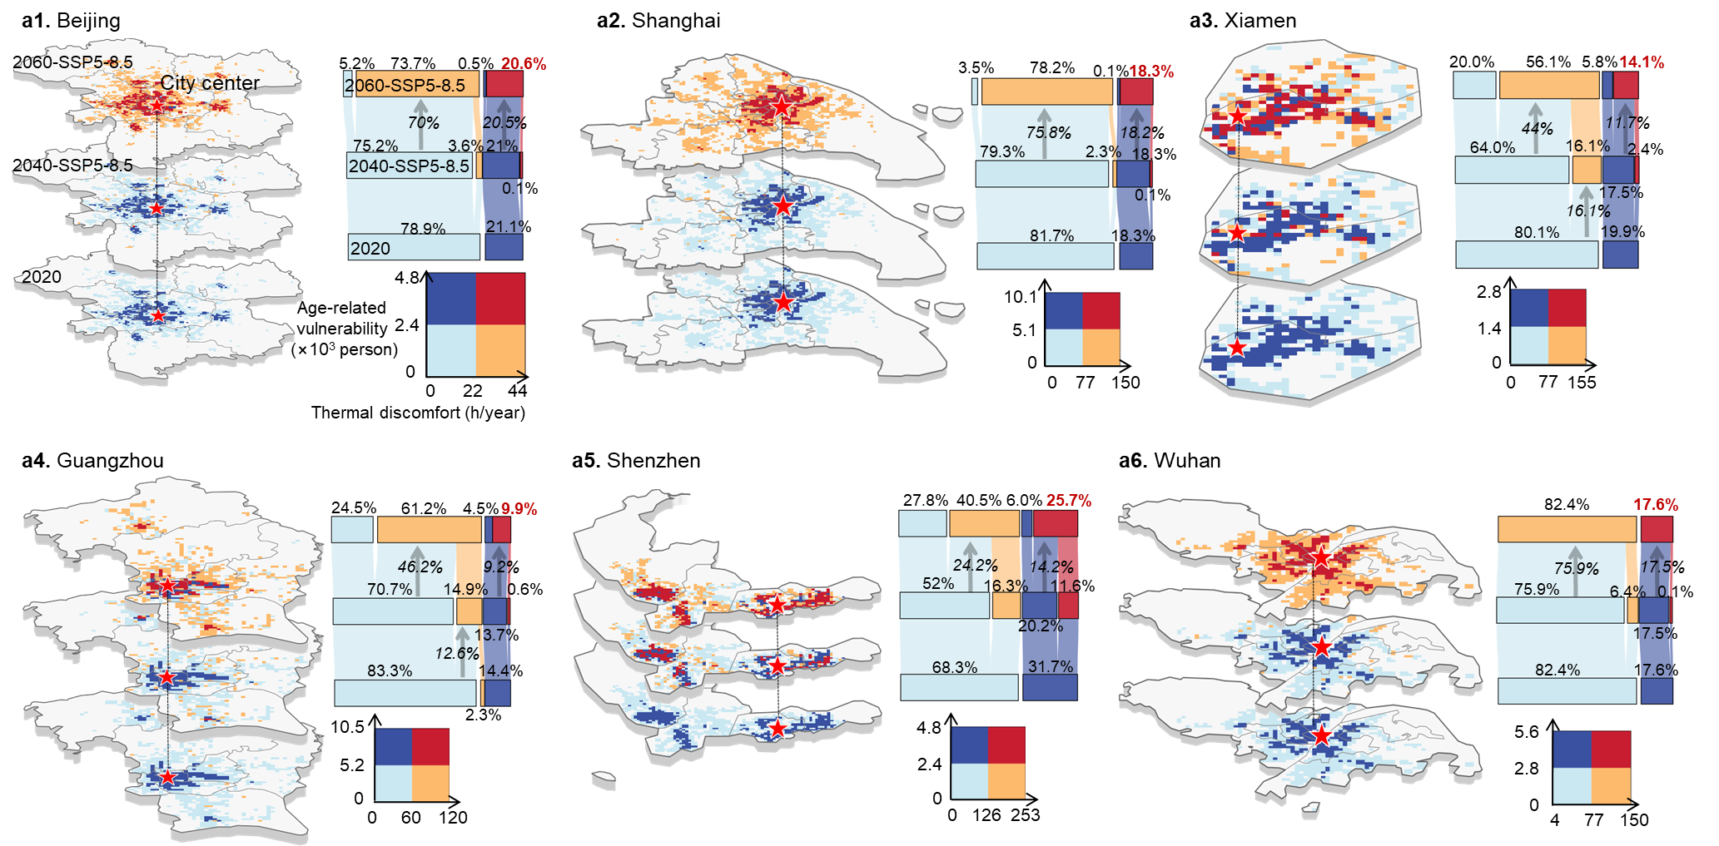
Fig. 5 Spatiotemporal evolution of the thermal-demographic co-vulnerability. a1–a6, Bivariate 3D spatial projections tracking the intersection of sleep-period thermal discomfort and age-related vulnerability (elderly populations) across six major Chinese megacities from 2020 to 2060 under the SSP5-8.5 scenario. The bivariate color matrix categorizes urban grids into four distinct quadrants: light blue denotes low-risk baseline areas; dark blue represents zones with high aging populations but low thermal stress; orange designates emerging physical hotspots of thermal discomfort with less susceptible younger demographics; and red signifies the critical zones concurrently suffering from severe nighttime heat and high concentrations of older adults. The accompanying flow diagrams quantify the structural shifts among these quadrants over time. Notably, the red zones, which are statistically negligible in 2020, exhibit a profound spatial convergence and expansion by 2060, transforming over one-fifth of the communities in cities like Shenzhen (25.7%) and Beijing (20.6%) into extreme “aging and overheating” demographic traps, predominantly clustered within mature city centers.

5 气候-能源-健康纽带（The Nexus）：应对机制与系统性代价
降低不舒适相应需要的空调能耗
Systemic cooling energy penalties and the energy-health trade-off under active mechanical adaptation

6 Discussion
To move beyond empirical correlations that directly link ambient temperature to population-level health outcomes, here we set out to bridge a critical yet underexplored gap between outdoor climate warming and human sleep health by explicitly accounting for the invisible buffering role of building envelopes and air conditioning systems. We developed a high-resolution, physics-based urban building energy and thermal comfort model, named the Building Energy Sand Table (BEST) and applied it to over 2 million individual buildings across 6 representative Chinese megacities across diverse climate gradient. By simulating hourly indoor thermal environments under baseline (2020) and three future climate scenarios (SSP1-2.6, SSP2-4.5, SSP5-8.5) and validating the results against geolocated social media complaints of heat-induced insomnia, we established a robust, transferable analytic engine that resolves the coupled dynamics of climate, building physics, human discomfort, and energy demand at an unprecedented building-by-building, floor-by-floor, and hour-by-hour granularity.
Our findings reveal four previously overlooked dimensions of climate vulnerability. 我觉得第一点应该说baseline睡眠影响小时，以及气候变暖会加剧到什么程度。然后才是你总结的三个建议
First, the “invisible building buffer” creates substantial spatial heterogeneity in thermal resilience: cities with similar outdoor climates (e.g., Guangzhou and Shenzhen) can exhibit markedly different indoor discomfort patterns and sleep disruption, owing to differences in building morphology, construction age, and urban form. Second, thermal inequality is not only horizontal but also vertical: top-floor residents suffer a systematic “top-floor penalty”, with nighttime discomfort hours being up to 50% higher than lower floors even within the same building, and this vertical disparity widens under more severe warming scenarios. Third, by overlaying demographic aging projections onto the simulated thermal maps, we identify an emerging “dual-vulnerability” hotspot—by 2060, more than 20% of the elderly urban population will experience severe heat-induced sleep loss, a co-exposure that has been largely ignored in conventional climate vulnerability assessments. Collectively, these results demonstrate that relying solely on outdoor temperature or aggregated city-level averages drastically underestimates the true burden of warming on sleep health and masks profound inequities embedded in the built environment. 这里还可以补一句，形成一个energy-comfort trade-off，如果加装XX空调能够缓解XX，但会导致XXX（这部分还没做完，可以留空）。
We acknowledged several assumptions. Our validation relies on geotagged social media posts (Weibo) reporting heat-related sleep disturbance. As social media users disproportionately represent younger, more active, and digitally connected demographics, while the most vulnerable groups, i.e., the elderly, low-income residents, and those with limited digital literacy, are systematically underrepresented in these data. Therefore, our spatial validation only confirms that the simulated indoor thermal patterns are consistent with the geographic distribution of observable complaints. More importantly, this bias implies that the actual thermal exposure and sleep risk for the silent, fragile population could be even higher than what our model–observation agreement suggests. Rather than weakening our conclusions, this under-reporting bias reinforces the policy urgency for those unexpressed but suffering hidden risks. Additionally, our current analysis does not incorporate adaptive behaviors (e.g., nocturnal window opening, fan use) or the age-dependent physiological sensitivity to thermal stress—both of which are promising directions for subsequent investigations.
Overall, this study transcends conventional climate-health studies by merging building physics, energy modeling with public health under global climate projections, offering a blueprint for cities to prioritize where, when and how to prevent the warming-induced sleep problems. The methodology is also scalable to other climate-vulnerable and intense cities.

Methods

Study design with high spatial-temporal-resolution
To quantify the actual physiological heat stress and the resulting cooling energy penalties for urban vulnerable populations in a warming climate, we developed an integrated and bottom-up framework centered on the buffering capacity of the built environment. Current climate vulnerability assessments frequently correlate outdoor ambient temperatures directly with human exposure. This simplification tends to overestimate the thermal threats by neglecting the mediating role of buildings. Our approach bridges this critical gap by explicitly modeling the buildings’ sheltering and buffering effects at an unprecedented spatiotemporal granularity.
To capture diverse climatic conditions, historical development trajectories, and architectural typologies, we selected six representative megacities in China as testbed: Beijing, Shanghai, Guangzhou, Shenzhen, Xiamen, and Wuhan, spanning the northern, eastern, southern, and central regions. In total, XXX buildings across these six megacities are investigated. The analytical pipeline integrates five interconnected dimensions: (1) Climate change scenarios, (2) Urban building energy modeling, (3) sleep-period discomfort simulation, (4) Validation of simulation results, and (5) Socio-human data fusion.

Climate change scenarios and urban meteorological forcing
To establish the evolving environmental boundary conditions, we first generated hourly meteorological forcing datasets for the six megacities. We utilized ERA5 reanalysis data to construct the baseline weather forcing for 2020, representing present-day climate conditions. For future climate trajectories, projections for 2040 and 2060 were sourced from the Coupled Model Intercomparison Project Phase 6 (CMIP6) under three Shared Socioeconomic Pathways (SSP1-2.6, SSP2-4.5, and SSP5-8.5).
We extracted daily climate variables including temperature, solar radiation, humidity, and wind speed from a robust ensemble of 15 CMIP6 models optimized for East Asia. These macro-scale projections were spatially downscaled via bilinear interpolation and subsequently converted to an hourly resolution using an established morphing protocol ⁶⁴. This downscaling approach effectively incorporates long-term climate-driven shifts through monthly mean shifting and variance stretching, while rigorously preserving the realistic diurnal temporal structures of the 2020 baseline typical meteorological year (TMY). Finally, the resulting full-year hourly meteorological datasets were compiled into EnergyPlus-compatible Weather files (.epw) to drive the physical urban building simulations detailed in the subsequent section. Extensive details for the morphing procedure can be found in Ref. ^{63,65}. Representative future TMY profiles are provided in Supplementary S4.

Urban Building Energy Modeling
Serving as the foundation for our assessment, we collected information for individual buildings across the six representative megacities, including the explicit locations, geometries, construction ages, and corresponding thermophysical properties, specifically envelope thermal transmittance (U-values), window-to-wall ratios, solar heat gain coefficients, and air infiltration rates. Based upon this spatially explicit inventory, we developed a bottom-up Urban Building Energy Modeling (UBEM) driven by the robust, physics-based simulator EnergyPlus⁵². By capturing the transient thermal dynamics of buildings under varying meteorological boundary conditions, our UBEM effectively translates prevailing outdoor climate forcing into realized indoor microclimates and the energy required to maintain indoor microclimates.
Given the computational scale required to simulate XXX buildings across decadal climate projections, our modeling pipeline necessitated strategic assumptions to balance computational tractability with physical fidelity. First, we implemented archetype-driven standardizations: spatial layouts were generalized by floor level, and HVAC configurations were assigned based on primary building typologies (e.g., split-unit air conditioners for residential buildings). Second, to standardize operational behaviors, static schedules for occupancy, internal heat gains (lighting and equipment), and characteristic thermostat setpoints were rigorously calibrated against China’s national Building Design Standards corresponding to each building’s construction era⁵³⁻⁵⁶. Third, to isolate the sleep-period thermal comfort variation under climate change, while other system-level factors such as renewable integration and efficiency improvements are assumed as constants in future projections. Detailed configurations on EnergyPlus simulation, including the specific infiltrations, internal gains, HVAC templates, and schedules, are provided in Supplementary S3.

Simulating sleep-period discomfort
To further translate the indoor microclimates into human physiological heat stress, we employed the Standard Effective Temperature (SET) as our core evaluation metric. Unlike simple air temperature, SET is a comprehensive biometeorological index that integrates indoor air temperature, mean radiant temperature (capturing the thermal radiation from the heated building envelope), relative humidity, and indoor air velocity. These transient variables were directly coupled from the UBEM outputs at an hourly resolution. We specifically isolated the sleep period (e.g., 22:00 to 08:00), as elevated nighttime temperatures critically disrupt the human body’s natural thermoregulatory recovery, representing a pivotal window of physiological vulnerability. To conceptualize the interplay between thermal exposure and adaptation under intensified future warming, we evaluated the sleep-period discomfort under two contrasting scenarios:
(i) In the baseline configuration, we constrained the air conditioning (AC) systems strictly to their current installation capacities and penetration rates. This existing AC setup affords a baseline level of sheltering currently, leaving only marginal discomfort hours. Our simulations reveal how projected future increasing outdoor temperature will breach the existing status, resulting in a surge of sleep-period discomfort hours.
(ii) To quantify the cost of maintaining absolute thermal safety for all, we employed the autosizing function within the EnergyPlus engine. This protocol simulates an adaptive environment where AC capacities and operational durations dynamically uncap and scale to perfectly fulfill any cooling load, thereby driving the indoor SET back into the comfort zone. Consequently, the building’s cooling Energy Use Intensity (EUI) would surge to artificially buy back sleep-period discomfort in a warming climate.

Two-tiered validation of both quantity and distribution
To ensure both the epidemiological fidelity and the spatial-behavioral robustness of our simulation, we implemented a two-tiered cross-validation, bridging macro-scale public health consensus with micro-scale empirical social feedback.
(i) At the fundamental physics-based modeling level, our configurations for simulation were first strictly benchmarked against national building codes and peer-reviewed publications [XXX]. Then, moving from building physics to human stress, the simulated magnitudes of per capita sleep-discomfort hours and the number of affected people demonstrated strong concordance when validated against well-recognized epidemiological assessments, notably the Lancet Countdown reports, as well as highly resolved regional findings published in recent peer-reviewed publications [XXX]. This top-down validation confirms that our derived physiological metrics accurately reflect the aggregate energetic realties and documented public health burdens of a warming climate.
(ii) Beyond epidemiological reports validate the quantitative magnitude of thermal risks, validating the spatial distribution of such risks requires unprecedented granular observations [XXNC]. To bridge this gap, we introduced an interesting spatial validation approach leveraging high-resolution social sensing networks. We performed targeted data mining on Weibo (China’s largest microblogging platform) to extract massive, geotagged user-generated texts during last 5 years summer heatwaves. By applying natural language processing logic to identify specific semantic markers of nocturnal heat stress (e.g., user-declared complaints of “too hot to sleep”), we reconstructed an empirical spatial distribution of real-world discomfort. Crucially, the spatial clustering of these geotagged physiological complaints aligned remarkably well with the theoretical “vulnerability hotspots” independently predicted by our building-level SET simulations (see Supplementary XX).
Such a multifaceted validation anchors our bottom-up simulation with both top-down authoritative medical reports and crowdsourced behavior, evidencing that our model accurately captures both the true magnitude and the hidden spatial heterogeneities of urban thermal inequalities.

Socio-human data fusion
To unmask the hidden spatial inequities in thermal vulnerability, our analytical pipeline couples the building-level physical simulations with high-resolution human geographies. Specifically, grid-level demographic censuses detailing the spatial distribution of physiologically sensitive cohorts (i.e., the elderly and children) were spatially explicit overlaid onto our building information inventory. This precise pixel-to-building alignment bridges the gap between thermodynamic building performance and localized demographic exposure, enabling us to pinpoint the vulnerability hotspots where the breach of building’s buffering disproportionately threatens sensitive populations.

For future climate projections (i.e., 2040 and 2060), we assume a stationary demographic structure, holding the spatial footprints and age distribution of these cohorts constant at the current baseline level. This assumption is justifiable for the selected megacities, as they are premier national economic hubs with a robust and sustained demographic pull. The continuous, large-scale influx of younger labor migrants effectively replenishes the demographic profile, counterbalancing natural aging trajectories and ensuring a relatively steady-state macro age structure. More crucially, from a study design perspective, constraining the demographic variables, allows us to strictly isolate and quantify the spatially heterogeneous risks driven purely by the climatic warming.

Data availability
列出用到的数据
（1）building info inventory including XXX buildings for six megacities, due to data privacy,
（2）hourly weather data for 2020 baseline and SSP1-2.6, SSP2-4.5, and SSP5-8.5 scenarios in 2040 and 2060
（3）
（4）

Code availability

Acknowledgment

Declare of interests

Reference

Supplementary

